September 2st, 2023

**{{ Titulo }} {{ Nombres }} {{ Apellidos }}**

**{{ Adscripcion }}**

**{{ Simposio }}**

**Chair ICSMV 2023**

Dear {{ Titulo }} {{ Apellidos }},

On behalf of the Organizing Committee of the XVI International Conference on Surface, Materials and Vacuum (XVI-ICSMV), I thank you for your important contribution as a Chair of the {{ Simposio }} symposium.

The ICSMV is an annual international meeting that offers an exciting multidisciplinary setting and an interactive forum to discuss advances in materials, surfaces, interfaces, and vacuum science.

<https://site.smctsm.org.mx/2023-conference/>

The Conference will be a hybrid event from September 25-29th, 2023 in Zacatecas, Zacatecas, Mexico. We will have the face-to-face event with the required interaction, complemented by the robust and user-friendly internet platform WHOVA, in combination with ZOOM. We are sure that your participation will greatly contribute to the success of the congress.

Sincerely yours,

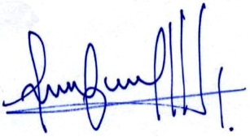

Mildred Quintana, Congress Chair